Trevor Haba

Video Game Proposal

Name Unknown

stalker game. Top down shooter, set inside a mansion (or a large series of rooms). The character is just a head that you can control to walk around, using WASD. The WASD controls will function like arrow keys, absolute up, down etc, not based on which way the player is facing. The game revolves around restricting the characters line of sight. When you enter a room, the walls and all other features will be revealed, but will be within the fog of war. Features within the fog of war will be displayed as a dotted line, and characters hiding in the fog of war will not be revealed. The player’s line of sight will comprise some arc “in front” of the player, centered on the cross hair, which will be controlled by the mouse. The cross hair will be restricted to a small circle around the player.

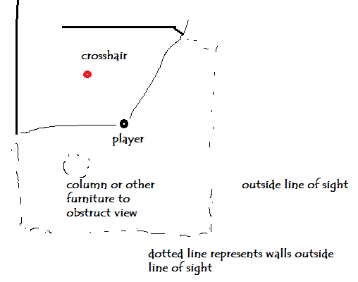

The player will be hunted and hunting several other AI controlled players with the same attributes.

Features:

Walk / run: the player will be able to hold shift to walk (or to run, not sure yet). Walking is slower but does not make noise. Will either program in directional sound or have a red indicator light when noise is coming from a nearby room. (find shortest route for sound to travel or multiply by a coefficient for each wall passed through…)

Gears of War action button: the player will be able to press space to either: leap or go into cover. Ability to lean against wall and then peak out:

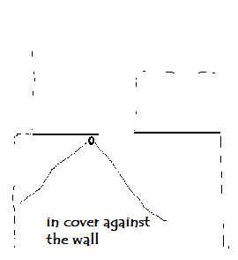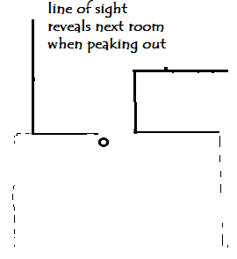

Same will work for windows distributed randomly throughout the rooms. Can peak through a window as if peeking through a wall

Leap will just move the player a good distance through the room. Good for avoiding enemies.

Can also leap through windows, which will break the window and make a noise. Can surprise enemies this way

Different weapons? Upgrades? Flashbangs / grenades?

Night mode: flashlights and such?

Melee: one hit kill Garrote, right click. Requires you to be close enough to right click on top of the enemy, i.e. they are within the restricted radius of the circle for the cross hair.

Game will revolve around intelligent AI challenging and often murdering the shit out of players.

Uses gears of war “action” button to do moves